Day 4 – More JS Basics

**(If you want to go right into the JS Shell you can depending on how things went yesterday.)**

**App Lab Exercise – Block and JS**

Show students the block version first and then how it looks in JS.

After the first one I want students to practice in JS not in block.

Let students play around with the exercise

**JS Shell 3 - Taxes!**

1. Add the script tag into the HTML
2. Add use strict
3. Declare variables (gross, fed, state, ss, medicare, net, grossTaxes)

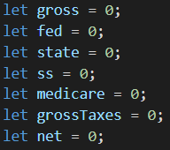

1. Use the selector function ($) to reference the calculate taxes button and monthly salary input element from the HTML (show students how to use inspect on browser to find the ids)



1. Use the calculateTax function to calculate each of the taxes.
2. Add the parameters for the print function (fed, state, ss, medicare, net)

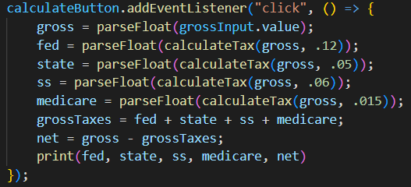

1. Check to make sure everything works.

**Break**

**JS Shell 4 – The Converterlator**

1. Add the script tag into the HTML to link the JS file and the css file.
2. Add use strict
3. Get the value from the value entered textbox.
4. Use an if statement to check if to Celsius is checked, OR to Fahrenheit is checked AND if the input is not a number. Inside that, add the text to the div, clear value entered, value computed, and select the value entered textbox.

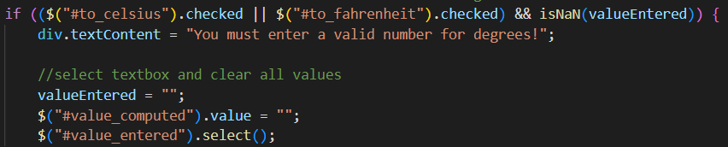

1. Add an else if checking if to feet is checked OR to meters is checked AND if the value entered is not a number. Inside that, Inside that, add the text to the div, clear value entered, value computed, and select the value entered textbox.

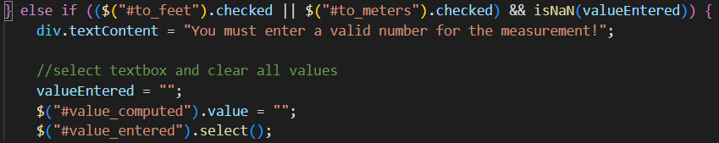

1. Add an else clause that is going clear any error messages and do our calculations for us.
2. Clear any error messages.
3. Add an if statement to see if to Celsius is checked. Inside that, set the value computed textbox to the function calculate Celsius with no decimal places. Select the value entered textbox.
4. Add an else if clause to see if to Fahrenheit is checked. Inside that, set the value computed textbox to the function calculate Fahrenheit with no decimal places. Select the value entered textbox.
5. Add an else if clause to see if to feet is checked. Inside that, set the value computed textbox to the function calculate feet with no decimal places. Select the value entered textbox.
6. Add an else clause. Inside that, set the value computed textbox to the function calculate meters with no decimal places. Select the value entered textbox.

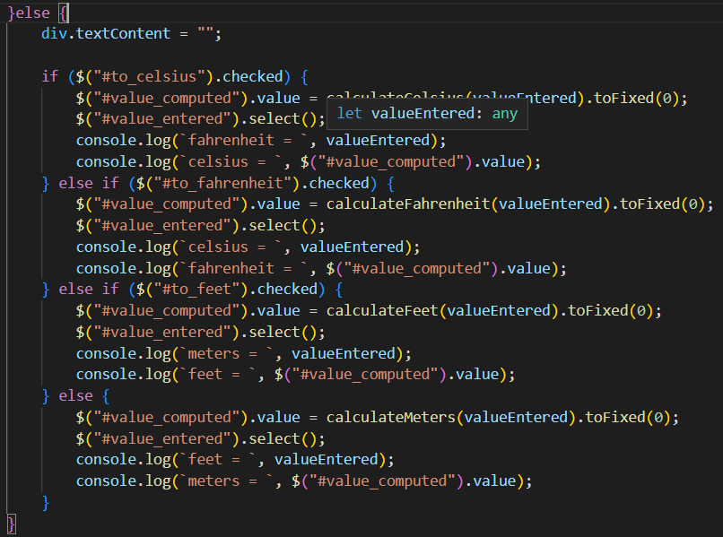

**Go over what we will be working on next week – React**